William Brown
Dr. Dehlinger
COSC 455-101
20 March 2026
Lol Code Project: Grammar
BNF Grammar:
<lolcode> ::= HAI <header> <body> KBYE
<header> ::= <comment> <header> | <head> | ε
<head> ::= MAEK_HEAD <comments> <title> MKAY
<comments> ::= <comment> <comments> | ε
<title> ::= GIMMEH_TITLE TEXT OIC
<comment> ::= OBTW TEXT TLDR

<body> ::= <body_item> <body> | ε
<body_item> ::= <comment> | <paragraph> | <list> | <bold> | <italics> | <link> | <newline> | <variable_define> | <variable_use> | TEXT

<paragraph> ::= MAEK_PARAGRAF <inner_paragraph> MKAY
<inner_paragraph> ::= <paragraph_item> <inner_paragraph> | ε
<paragraph_item> ::= <list> | <bold> | <italics> | <link> | <newline> | <variable_define> | <variable_use> | TEXT

<bold> ::= GIMMEH_BOLD TEXT OIC
<italics> ::= GIMMEH_ITALICS TEXT OIC

<list> ::= MAEK_LIST <list_items> MKAY
<list_items> ::= <item> <list_items> | ε
<item> ::= GIMMEH_ITEM <inner_list> OIC
<inner_list> ::= <inner_list_item> <inner_list> | ε
<inner_list_item> ::= <bold> | <italics> | <variable_use> | <variable_define> | TEXT

<link> ::= GIMMEH_LINX ADDRESS OIC
<newline> ::= NEWLINE

<variable_define> ::= IHAZ VARNAME ITIZ VALUE MKAY
<variable_use> ::= LEMMESEE VARNAME OIC

ANTLR Test Cases
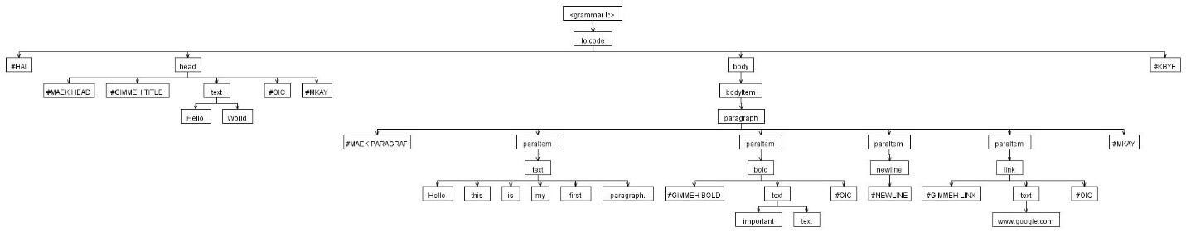
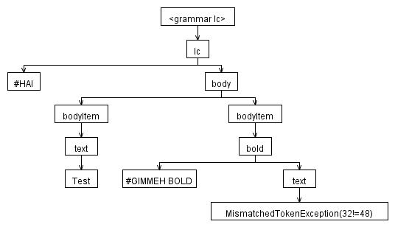
DFA Chart:
